DELIVERING THE NEWS TO COMMUNITIES IN CRISIS

How To Use This Guide. The recommendations here are concerned with authenticity, because an authentic communicator is more likely to be a trusted communicator.

Following an introduction, they are divided into three sections – MANAGING YOUR THINKING, MANAGING YOUR SPEAKING and MANAGING YOUR DOING. Each of us is actually a communicating system, and there is a profound and symbiotic relationship between the various parts of that system. How you move affects the way you sound and the way your brain works, and vice versa. Changes in one part of the system will trigger changes in the other parts.

So, feel free to work with whatever feels most accessible – and authentic – to you. Work you do on any one area of your delivery will almost certainly have a positive impact on other areas without you having to do anything else at all. And as viewers sense they are getting a “real” you, they will be more likely to believe they are getting a you that can be trusted.
Barry Nash

We know from research that, even in the best of times, you really can’t separate the story from the storyteller. When it’s most critically important to get the facts right, it’s critically important to get your delivery right. How you deliver the news – not just what you say but also how you say it – is never more important than when you are addressing your community in a time of crisis and fear.
Even in the best of times, viewers have been increasingly critical of anchors and reporters that seemed fake or contrived to them. In times of fear and anxiety, the hunger for authenticity is amplified. When viewers are desperate for information they can trust, they naturally turn to people and organizations they can trust – and in delivery authenticity resonates trustworthiness. If you are being real with me – if you are truly talking to me and not at me – I am more compelled to listen and to trust the things you have to say to me.
Research has shown that authenticity that engenders trust is not something most human beings can effectively fake – at least not for any length of time. It’s not something you can put on display, like your ability to read flawlessly or to make a timely comment. It’s not a function of competence or reliability, though both are qualities that may contribute to it. If you are pretending to know or pretending to care, people will get it. It will turn them off, and they will turn you off.
Trust is a matter of relationship. In his book, building trust in business, politics, relationships and life, reknowned business consultant Fernando Flores writes that authentic trust is developed “through interaction and conversation.” You do not cultivate trust by talking at the viewer but by talking to her. This gives important weight to the idea of speaking authentically and conversationally. To deliver the news in a way that builds trust, the experience needs to feel like a sharing of something between you, not like a performance.
Fernando Flores
And it needs to be clear that you care. In fact, Flores writes, “Care is perhaps the most essential ingredient of authentic trust, not only care about the immediate outcome but care about the relationship.” It’s no accident that the most memorable moments in the history of news delivery are demonstrations of caring. Walter Cronkite announcing the death of a president and the first steps on the moon. Peter Jennings calculating the toll of 9/11. Anderson Cooper embracing the mother of a young man slain in Orlando. In these instances, viewers could see that the anchors were not just delivering facts. They cared. Delivery that nurtures trust is delivery that is somehow infused with a sense of your caring – about the news and about the viewers you are sharing it with.
Please note: You should not attempt to imitate or manufacture moments like these, but to learn from them. They happened because each of these anchors, in his own way, brought empathy and caring to the moment at hand. Your job is to care and to let your own caring inform the work you do. It is not to imitate others’ ways of caring, no matter who they are.
This does not mean that your reporting should in any way be subjective as far as the content of a story is concerned. We are talking here about your passion and caring for the work itself and your relationship with your community of viewers, not about passion for one side of an argument or the other.
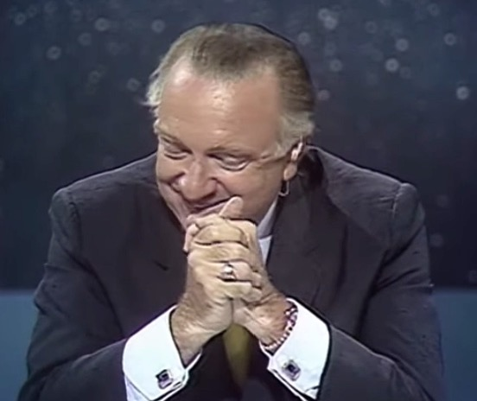
There are, of course, things you can and should be subjective about. The loss of a child is tragic. The image of man walking on the moon for the first time is awe-inspiring. The emotions associated with moments like these are at times evidence of our shared humanity, not violations of any journalistic standard. Our inability to control a virus that is killing friends and relatives is terrifying. It makes sense that viewers would be more trusting of talent who care about these things like they do.
Cronkite: "Wally, say something. I'm speechless."
This also does not mean that you should ever feel pressure to manufacture overt emotional display. It is possible to show empathy and understanding without modeling viewer reaction, like a doctor with good bedside manner delivering difficult news to a patient. She does not have to cry with the patient to communicate empathy and to prove that she cares about what the news she is sharing is doing to him.
So, how can you manage your delivery so that it is professionally responsible and also nurtures viewer trust, especially at a time when trusting you and the news you’re sharing is so critically important to the communities you’re serving?

First, it’s important to understand that, pandemic or no pandemic, there is always a preference for authenticity – for talent who seem “real” to viewers. In research, it’s not unusual for viewers to describe their preferred talent with a comment like this: “It feels like she is talking to me. The others just seem to be reading and talking at me. It’s more like a conversation than a performance.”

This may be especially important to the generations now in the demo, many of whom have been talking to others on Facetime for as long as they can remember. They literally grew up experiencing on-camera conversation as an everyday thing, so their radar for anything not authentic may be particularly acute. If you can’t be in what feels like a conversation to them, they are simply not interested. There are lots of ways to stay informed. They don’t need you.
Facetime Generations

For many, the coronavirus pandemic has changed that. At least temporarily, you have information they do need, and many are seeking you out who otherwise would not. So, how will the “conversation” with you feel to them? Like a performance, or like you understand what concerns them and authentically care about it? Will there be anything about it that will leave them wanting more time with you even when the current crisis is history?

We hope the thoughts and recommendations here will help you answer those questions.

______________________________________________________________________________

MANAGING YOUR THINKING

First and foremost, authenticity is a function of preparation. To communicate authentically you have to be authentically prepared. The research teaches that it is almost impossible to fake authentic engagement for any sustained period of time – and the ways we routinely fake it in many organizations has surely contributed to the impression that we are not real and that viewing us regularly is not essential. You cannot effectively pretend to know. You have to do the work of really knowing. You cannot effectively pretend to care. Or to listen. Or to ask questions you haven’t personally considered.

If you are going to be authentic, you have to begin by being relentlessly honest with yourself about the ways you have been faking it, and you have to do the hard work that will ensure once you’re on the air that you do know, you do care, you are really listening, and the questions are a function of your attention and concern.
Talk to viewers like they are people you know and care about. How you think about viewers has the power to change how they think about you. Consider how your "delivery" in everyday life changes based on who you're talking to. The tone and spirit of your conversation with people you know and care about (friends, significant others, your dog) will be fundamentally and recognizably different from the tone and spirit of your conversation with folks you don't know as well.
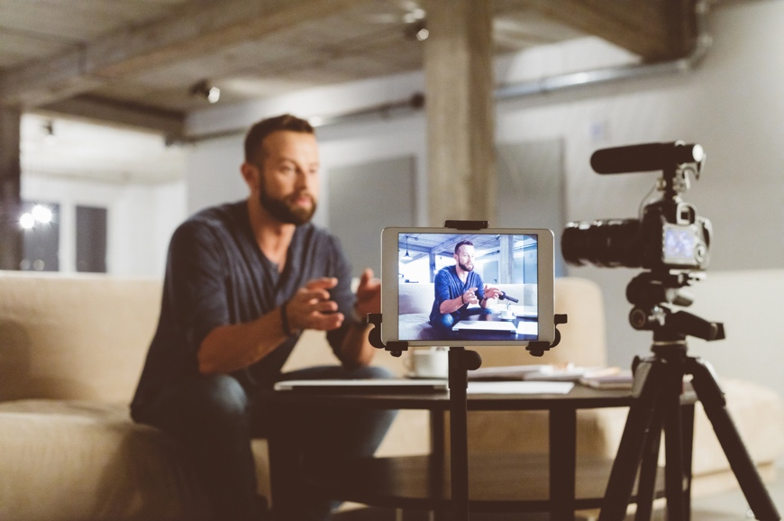
Human communication evolved based on our ability to see and hear each other. Talking to a machine is fundamentally inhuman.

Talking to a machine is fundamentally inhuman.

When you are on television, the audience is always a product of your imagination. You cannot see them, you cannot hear them — you are in an imagined conversation. How you imagine them will fundamentally and recognizably change the quality of your delivery to them.
Consider what the emotional impact the news will have on viewers. Connecting sincerely and compassionately with viewers requires that you understand and respect where they are emotionally. Empathy is a powerful journalistic tool, but it's not as simple as “I know how you feel,” because honestly, you don’t. But you DO know what it feels like to be afraid of the unknown, to not know whether everyone you love is safe, to miss or even mourn a loved one or close friend, and to be afraid you won’t be able to work and care for those you care about. This is where viewers are right now. Empathy does not mean you “get it.” Empathy means “I care about you, I want to be here, with you, right now, in this moment. We will experience this together.” We cannot “fix” it, we cannot “make it right,” but we can be there for one another, experiencing the fears, supporting the courage. So, before you write that story, before you go on camera, take a personal moment to reflect on where your viewer is emotionally. Just taking the time to consider it will effectively inform the tone of your delivery.

Showcase what you’re learning and, when possible, how you’re learning it. A commitment to “process” reporting and transparency may be especially important when you are working from home, because it reminds us of how you are connected beyond the home – and why we need you. It reminds us that, though on the face of things it looks like you are confined, just like we are, your “reach” is much bigger than that. When you talk about who you talked to, what you asked, etc., it helps us appreciate that. And it reinforces our gratitude that you are there and working.

Think like a pilot, not like a passenger. This means, fundamentally, that your instinct is to believe a solution is possible and to pursue it relentlessly. Great leaders are those who can both see the reality and keep their heads in the face of it enough to see past it. Sully Sullenberger, the pilot who famously and safely landed his plane in the Hudson River, says that as soon as he recognized the problem his instinct was to find a way to solve it. Instead of being overwhelmed by the present, he was immediately thinking and looking ahead. And he has said that, before he made his one announcement to “Brace for impact,” he thought specifically about what he wanted his voice to convey when he said it. When we say we trust you, we are making a statement about the future. We are talking about who we believe you will be in future circumstances and under certain pressures. When you are sounding the alarm about Covid-19 and telling your viewers to “brace for impact” day after day, what do you want viewers to sense and hear in you? Panic? Hopelessness? Resolve that, if we keep looking and helping each other, we’ll find a way to land the plane? Better to think like the leader in the cockpit looking and planning ahead than like a passenger in the back, who is powerless to do anything but brace for impact.
Sully Sullenberger: “Brace for impact.”
______________________________________________________________________________

MANAGING YOUR SPEAKING
Plan to talk like you talk. I am isolated in my home. I crave connection and conversation. The way that you speak to me posits the relationship you believe you have with me, and it does not help if you talk to me in ways that overtly remind me we are not in conversation. While it’s always useful to ask whether grammatical constructions you’d never use in “real life” serve you well on-the-air, it may be especially important awareness at a time you want viewers to feel you understand them, that you are not just performing for them. In the note above I talked about the way a segment can bring viewers closer. The way you choose to talk – the language you choose to use – can have the same effect.
Speak with energy, conviction and confidence. If you are not careful, working in a home environment can subtly undermine the energy of your delivery. You are physically isolated in an environment normally associated more with relaxing than with working. Take time to think about what you most need viewers to learn and understand, and then deliver that message with force and conviction.

A sense of authentic confidence (not bravado) is especially important in times of fear. When people are afraid, they are grateful and drawn to leaders who are clearly know what needs to be done and can speak with the purpose and authority that go with that.
Speak at a conversational volume level. Don’t make the mistake of equating energy with projection. Volume will reveal whether you are talking to us or at us – and whether you are in control or losing it. Leaders are distinguished by the ability to stay calm when others are not. They are not the ones screaming, “Oh my god, the building is on fire! We’re all going to die!” They are the ones who take us by the hand and lead us out of the building.
Volume is also the way we signal our interest in connecting – or not – with the people we are talking to. In moments of real connection, we do not project past the listener. We speak just loudly enough to reach them. When we are louder than we need to be, we may want attention and we may want to dominate, but it’s obvious we do not want to connect.
(The best lecture on volume we’ve ever seen on volume is this 10-minute excerpt from a talk by voice and speech guru, Patsy Rodenburg. She is talking to actors in this clip, but her explanation of what volume says about manipulation and connection is absolutely on point for television news talent.)
Honor the emotional complexity of the news in your report or program. In difficult times, when there are opportunities for something other than bad news – something positive or hopeful or humorous – it’s especially important that you be up to expressing it. When the emotional quality of what you are sharing does change, viewers should hear it in your voice (and see it in your face).
Rodenburg (photo by Stuart Allen)
______________________________________________________________________________

MANAGING YOUR DOING
Move and gesture when you’re speaking. Movement reinforces your expertise, your leadership – and your trustworthiness. Researchers at MIT have shown that leaders and people who know what they are talking about communicate with “high activity” in the body (and in the voice). In other words, when we really know what we are talking about, we tend to move while we talk about it. And other studies have shown that expressive people are both liked and trusted more than those who are not.
Gesture, in particular, enhances other important dynamics. When you gesture you have more facial expression. You also are more likely to speak conversationally, because research has shown that we use gesture to manage the rhythm of our speech.
Moreover, your brain just works better when movement is not constrained. You can remember things more quickly and easily, and you use language more creatively. Even if the shot is tight enough that the movement happens off camera, it’s still important that you continue to express yourself physically as well as verbally.
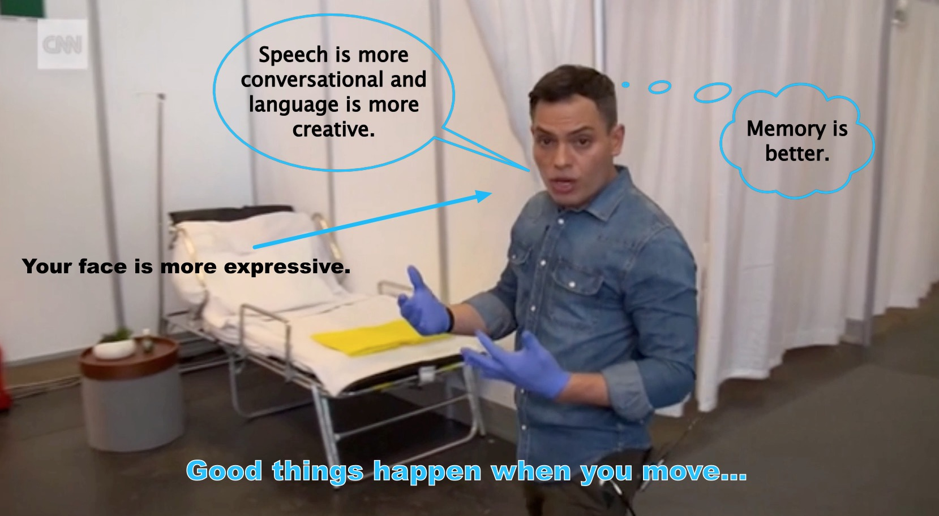
Stop moving when you’re listening. Research has also shown that the one time all movement stops is when we are authentically listening. Shuffling paper or any other extraneous activity while someone else is speaking signals to the rest of us that we do not have your full attention. Basically, you should be as focused and your listening should have as much energy as your speaking does.
Sitting or standing, work toward the camera like you would in the studio. Moving and gesturing toward someone is a way of showing interest in them or demanding their attention. In a subtle way, it brings you even closer to me, the viewer.
When possible, physically use whatever is around you. If your monitor can function for you as something other than set dressing, make the most of it. It will visually strengthen your story and, in most cases, it will make it easier to move and speak in a way that looks and sounds more authentically conversational.
______________________________________________________________________________

WANT TO CONTINUE THE CONVERSATION?

We’re committed to doing all we can -- including offering opportunities for complimentary coaching -- to support television newscasters and newsrooms working to help communities understand and navigate the Covid-19 pandemic. You can read more here.

Also, the conversation about delivery goes on daily at our private Facebook group for television newscasters, Delivering News When the News Hurts: News Talent in Times of Crisis. We’d love for you to join us. Just use this link to apply for admission to the group.

